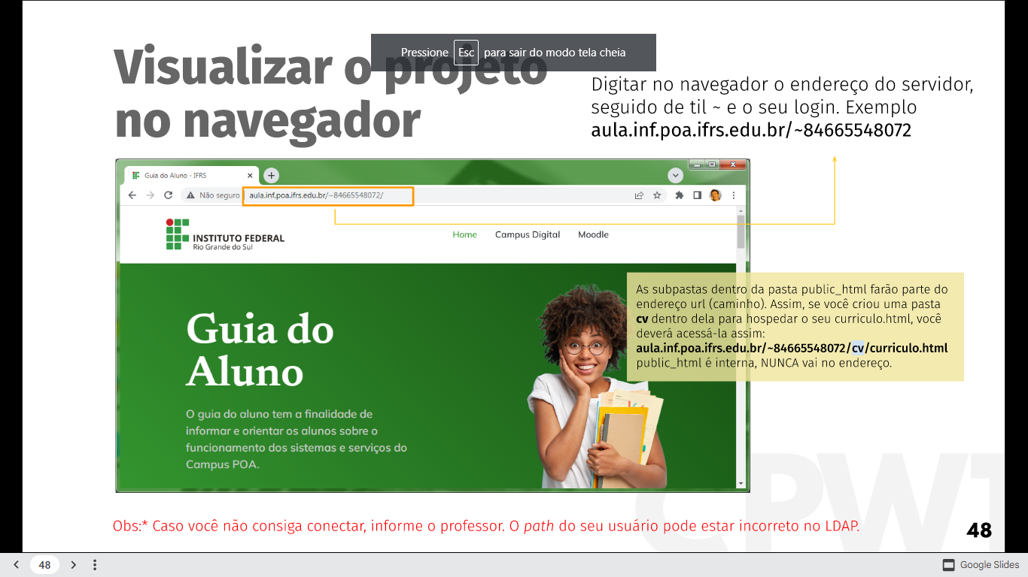

http://aula.inf.poa.ifrs.edu.br/~97221074020/index.html